Mission Statement of the Department.
To nurture computer engineering professionals by offering Dynamic learning environment that encourages problem-solving using emerging technology, National Education Policy aligned evidence-based technical education, fostering ,innovation, research, and industry–institute collaboration & Holistic, ethical and sustainable development for lifelong success.

Session 2026-2027

Vision:Dream of where you want. | Mission: Means to achieve Vision

Program Educational Objectives of the program (PEO): (broad statements that describe the professional and career accomplishments)
PEO1 | Preparation | P: Preparation | Pep-CL abbreviation pronounce as Pep-si-lL easy to recall
PEO2 | Core Competence | E: Environment  (Learning Environment) | Pep-CL abbreviation pronounce as Pep-si-lL easy to recall
PEO3 | Breadth | P: Professionalism | Pep-CL abbreviation pronounce as Pep-si-lL easy to recall
PEO4 | Professionalism | C: Core Competence | Pep-CL abbreviation pronounce as Pep-si-lL easy to recall
PEO5 | Learning  Environment | L: Breadth (Learning in diverse areas) | Pep-CL abbreviation pronounce as Pep-si-lL easy to recall

Program Outcomes (PO): (statements that describe what a student should be able to do and know by the end of a program)
Keywords of POs:
Engineering knowledge,Problem analysis, Design/development of solutions,Conduct Investigations of Complex Problems, Engineering Tool Usage, The Engineer and The World,Ethics, Individual and Collaborative Team work,Communication, Project Management and Finance, Life-Long Learning

PSO Keywords: Cutting edge technologies, Research

“I am an engineer, and I know how to apply engineering knowledge to investigate, analyse and design solutions to complex problems using tools for entire world following all ethics in a collaborative way with proper management skills throughout my life.” to contribute to the development of cutting-edge technologies and Research.

Integrity: I will adhere to the Laboratory Code of Conduct and ethics in its entirety.

Name and Signature of Student and Date
(Signature and Date in Handwritten)

Mission Statement of the Department.
To nurture computer engineering professionals by offering Dynamic learning environment that encourages problem-solving using emerging technology, National Education Policy aligned evidence-based technical education, fostering ,innovation, research, and industry–institute collaboration & Holistic, ethical and sustainable development for lifelong success.

Session | 2026-27 (ODD) | Course Name | Web Technology Lab
Semester | 3 | Course Code | 23CT1301
Roll No | 57 | Name of Student | Prasun Kachhwah

Practical Number | 5
Course Outcome | - Understand various internet technologies.  - Design the web pages using HTML and CSS.  - Implement the XML technology to store the data.  - Develop the interactive web pages using JavaScript.
Aim | JavaScript — Events & Interactivity
Problem Definition | Build ONE interactive app — a Calculator OR a short Quiz (pick one) — that responds to clicks/key-presses and updates results dynamically, demonstrating event handling.
Theory  (100 words) | JavaScript events are actions or occurrences detected by the browser, such as user interactions or system processes, that allow web pages to respond dynamically. Interactivity is achieved through event listeners, which execute specific code when these events occur, enabling features like form validation, dynamic content updates, and responsive user interfaces without page reloads.  Common event types include:  - MouseEvents: click, dblclick, mouseover, mouseout, mousedown, mouseup, and mousemove.  - Keyboard Events: keydown, keyup, and keypress.  - Form Events: submit, reset, change, focus, and blur.  - Window Events: load, unload, resize, and scroll.  - Touch Events: touchstart, touchend, and touchmove.  The modern standard for handling events is  the addEventListener() method, which attaches an event listener to an HTML element. This approach keeps HTML and JavaScript separate,
To nurture computer engineering professionals by offering Dynamic learning environment that encourages problem-solving using emerging technology, National Education Policy aligned evidence-based technical education, fostering ,innovation, research, and industry–institute collaboration & Holistic, ethical and sustainable development for lifelong success.
 | allows multiple listeners for the same event, and supports event propagation control (capturing and bubbling) via the third argument.
Procedure and Execution  (100 Words) | Step for Implementation:  Open a text editor (such as VS Code, Notepad, or Sublime Text).  - Create a new file named practical4a.html.  - Set up the standard HTML structure (<!DOCTYPE html>, <html>, <head>, <body>).  - Add an interactive element, such as an input field and a <button>, to trigger JavaScript execution.  - Define a JavaScript block inside <script> tags or link a javascript file to add functionality to your project  - Save the file and open practical5.html in a web browser.  - Click the button to observe dynamic content changes and inspect the browser console (F12) for output.
Procedure and Execution  (100 Words) | Code: HTML:  <!DOCTYPE html>  <html>  <head>  <title>  Calculator  </title>  <link rel="stylesheet" href="style.css">  </head>  <body>  <div class="calc_body">

To nurture computer engineering professionals by offering Dynamic learning environment that encourages problem-solving using emerging technology, National Education Policy aligned evidence-based technical education, fostering ,innovation, research, and industry–institute collaboration & Holistic, ethical and sustainable development for lifelong success.
<div class="display">

</div>

<div class="buttons">

<button type="button" id="seven"> 7 </button>
<button type="button" id="eight"> 8 </button>
<button type="button" id="nine"> 9 </button> <button type="button" id="plus"> + </button>
<button type="button" id="four"> 4 </button>
<button type="button" id="five"> 5 </button>
<button type="button" id="six"> 6 </button>
<button type="button" id="minus"> - </button>
<button type="button" id="one"> 1 </button>
<button type="button" id="two"> 2 </button>
<button type="button" id="three"> 3 </button>
<button type="button" id="mul"> * </button>
<button type="button" id="clear"> C </button>
<button type="button" id="zero"> 0 </button>
<button type="button" id="equal"> = </button>
<button type="button" id="divide"> / </button>

</div>

</div>

<script src="script.js"> </script>

</body>

</html>

JAVASCRIPT:

const display = document.querySelector('.display'); let operator;

let one = document.querySelector('#one'); let two = document.querySelector('#two'); let three = document.querySelector('#three'); let four = document.querySelector('#four'); let five = document.querySelector('#five');
To nurture computer engineering professionals by offering Dynamic learning environment that encourages problem-solving using emerging technology, National Education Policy aligned evidence-based technical education, fostering ,innovation, research, and industry–institute collaboration & Holistic, ethical and sustainable development for lifelong success.
let six = document.querySelector('#six'); let seven = document.querySelector('#seven'); let eight = document.querySelector('#eight'); let nine = document.querySelector('#nine'); let plus = document.querySelector('#plus'); let minus = document.querySelector('#minus'); let mul = document.querySelector('#mul'); let divide = document.querySelector('#divide');

let clear = document.querySelector('#clear'); let equal = document.querySelector('#equal');

zero.addEventListener("click",function() { displayInput(zero.innerText);
});
one.addEventListener("click",function() { displayInput(one.innerText); }); two.addEventListener("click",function() { displayInput(two.innerText); }); three.addEventListener("click",function() { displayInput(three.innerText);
});
four.addEventListener("click",function() { displayInput(four.innerText);
});
five.addEventListener("click",function() { displayInput(five.innerText);
});
six.addEventListener("click",function() { displayInput(six.innerText); }); seven.addEventListener("click",function() { displayInput(seven.innerText); }); eight.addEventListener("click",function() { displayInput(eight.innerText);
});
nine.addEventListener("click",function() { displayInput(nine.innerText); });

plus.addEventListener("click",function() {
operator = plus.innerText; displayInput(operator);
});
minus.addEventListener("click",function() { operator = minus.innerText; displayInput(operator);
});
mul.addEventListener("click",function() {
operator = mul.innerText; displayInput(operator);
});
divide.addEventListener("click",function() {
operator = divide.innerText;
To be a preferred hub for nurturing computer engineering aspirants through innovative, ethical, value-based technical education, impactful research, and industry collaboration, to become successful professionals contributing for the betterment of society.
Mission Statement of the Department.
To nurture computer engineering professionals by offering Dynamic learning environment that encourages problem-solving using emerging technology, National Education Policy aligned evidence-based technical education, fostering ,innovation, research, and industry–institute collaboration & Holistic, ethical and sustainable development for lifelong success.
displayInput(operator);
});

clear.addEventListener("click",function() { clearAll() }); equal.addEventListener("click",function() { calcAll() });

function displayInput(value) { display.innerText += value;
}

function clearAll() { display.innerText = '';
}

function calcAll() { let values = display.innerText.split(operator); const num1 = parseInt(values[0],10); const num2 = parseInt(values[1],10);

if (operator == '+') { display.innerText = num1 + num2;
}
else if (operator == '-') { display.innerText = num1 - num2;
}
else if (operator == '*') { display.innerText = num1 * num2;
}
else if (operator == '/') {
if (num2 == 0) { display.innerText = "♾"; } else { display.innerText = num1 / num2; }
}
}

To be a preferred hub for nurturing computer engineering aspirants through innovative, ethical, value-based technical education, impactful research, and industry collaboration, to become successful professionals contributing for the betterment of society.
Mission Statement of the Department.
To nurture computer engineering professionals by offering Dynamic learning environment that encourages problem-solving using emerging technology, National Education Policy aligned evidence-based technical education, fostering ,innovation, research, and industry–institute collaboration & Holistic, ethical and sustainable development for lifelong success.
Output:
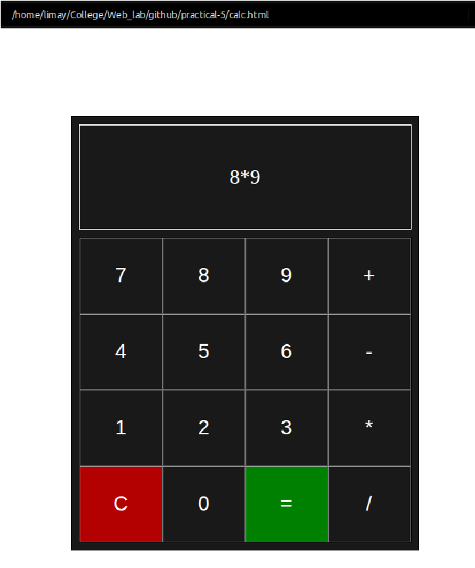

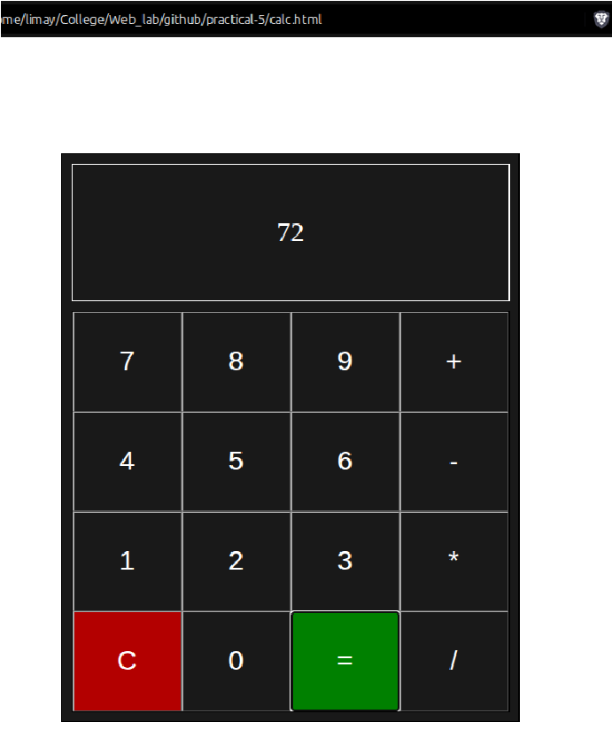
Output Analysis | The browser displays the nicely built calculator.  The buttons have a hover effect and get display on the screen <div> when pressed.  The operations buttons are also functional and the “=” buttons computes and displays the output.  The “C” clears the output.
To be a preferred hub for nurturing computer engineering aspirants through innovative, ethical, value-based technical education, impactful research, and industry collaboration, to become successful professionals contributing for the betterment of society.
Mission Statement of the Department.
To nurture computer engineering professionals by offering Dynamic learning environment that encourages problem-solving using emerging technology, National Education Policy aligned evidence-based technical education, fostering ,innovation, research, and industry–institute collaboration & Holistic, ethical and sustainable development for lifelong success.
Link of student Github profile where lab assignment has been uploaded | https://github.com/PrasunKachhwah
Conclusion | Successfully studied the some event handlers of JavaScript and demonstrated built a client side application.
Plag Report (Similarity index < 12%) | 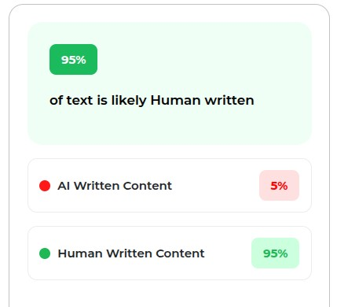
Date | 22/09/2026

